

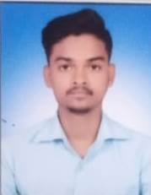

Ref No : TEC/2024/03

**TO WHOM IT MAY CONCERN**

This is to certify that **Mr. Ajit sharma S/O Sri Ramchandra sharma** has beenworking in our organization as a **“COMPUTER TEACHER”** from 06th July 2022 to till date. Working time is 07:00 – 01:00 PM.

Mr. Ajit Sharma was responsible for:-

1) Delivering engaging and interactive computer lesson to

students.

2) Preparing lesson plan, study materials and conducting

assessments.

3) Guiding students in practical Ms. office and accounts ( Tally ) and IT

application.

He is hardworking, dedicated and reliable professional with excellent communication and technical skill. His ability to connect with students and simplify complex topic has been commendable.

We are confident that he will excel in his future endeavors and contribute significantly to any organization he joins.

We wish him all the best in his future career.

For THE EUROPEAN Date :- 04-12-2024